**Concept Selection**

**HOQ**

|  |  |  |  |  |  |
| --- | --- | --- | --- | --- | --- |
|  |  | Engineering Characteristics | | | |
| **CUSTOMER REQUIREMENTS** | CI (1-5) | Number of Parts | Continuity | Aesthetics | Change in Height |
| Fashionable | 5 |  |  | 10 | 8 |
| Cost Effective | 2 |  |  |  | 4 |
| Variable Height | 5 | 1 |  |  | 10 |
| Ease of Use | 4 | 10 | 10 |  |  |
| Support Human Weight | 4 |  |  |  | 6 |
| Stable During Operation | 3 | 6 |  |  | 10 |
| **SCORE** | | 63 | 40 | 50 | 152 |
| **RELATIVE WEIGHT** | | 0.21 | 0.13 | 0.16 | 0.50 |
| **RANK (Highest to Lowest)** | | 2 | 4 | 3 | 1 |

The HOQ resulted in the most important engineering characteristic being the ability to change height which is logical because that is the entire purpose of the project. Second was the number of parts because the more parts then the harder it is to manufacture, the more likely an individual parts might break and the harder the shoe would likely be to operate. Third was aesthetics which probably should’ve been ranked higher due to the importance of this from the customer requirements. Lastly was continuity which was not a direct customer requirement of a want from the survey data. Continuity simply refers to whether the heel is removable or if the design stays in one piece the entire time.

**Slider Design**

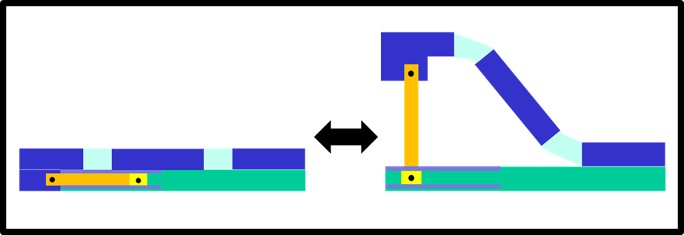

This prototype is inspired by the three-bar mechanism design concept. It features a bar attached by pin joints between the heel and a slider in a track in the sole. All the wearer would have to do to change the shoe from a flat to an elevated state is move the slider along its track. In an actual version of this design, a simple locking mechanism would need to be added to keep the slider from moving along the track unintentionally (which would almost certainly lead to the wearer falling). A flexible sole would be employed to aid in the transition between states. A folding, origami casing can be used to hide the heel mechanism if the mechanism can not be made to look fashionable. The height of the heel can be easily set by changing the length of the heel bar. The sole itself has no mechanisms in it and can easily be designed in a comfortable, ergonomic manor.The design has five main parts: the base, the sole, the heel bar, the track, the slider. A simple locking mechanism may add more parts if it is not integrated directly into the track.

The pro’s of this design concept is that it is simple to change states as all users need to do is move the slider. This design is also relatively simple to design. The con’s is that this design will require a base separate from the actual sole, and this base will have to be at least as thick as the heel bar (Which must be thick enough to support the wearer’s weight) with the actual sole on top of this base.

**Flip and Slide Design**

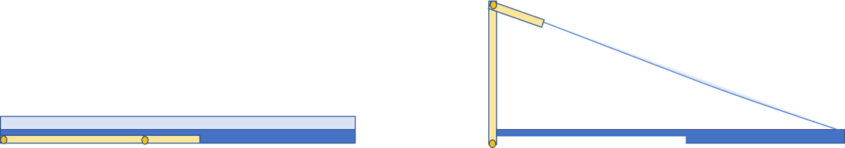

This design is inspired by the hug-slide concept previously mentioned. This is a two bar linkage system with two pin joints. One pin joint is secured at the base of the heel of the shoe an additional pin joint is secured on the rotational piece and is the desired heel height away from the first joint. The insole and out sole are two separate parts and a locking mechanism is located on both the insole and the outer sole to secure the rotational piece during its various states. This design has numerous parts and aesthetically isn’t the most stylish and would only be available in a wedge style. This design does allow for a change in height and has no removable pieces so it scores high for continuity and heel height change.

**Folding Heel Design**

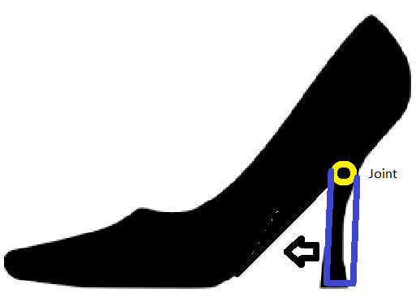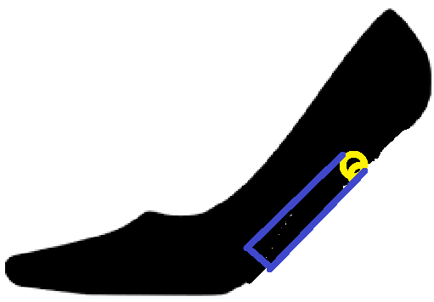

This design uses a joint at the top of the heel to convert from an elevated to flat state. The heel would fold into the bottom of the shoe when changing from an elevated to flat state. The simplicity of the design would be one of its greatest proponents. The usability of the shoe would be high meaning the the transition would be easy to do. The only component needed to be engineered specifically for this design would be the heel which could still be altered for aesthetic purposes, the rest of the shoe could be designed around the fashion aspect. The change in heights would allows for a elevated 3 inch heel to a flat 0.5 inch shoe which would be due to the large bottom sole of the shoe and not a lower heel height. This design allows for only 1 elevated shoe height but would contain no removable parts. The design of the shoe could be altered in order to appear as a normal high heel and would not require a wedge design.

**Removable Heel Design**

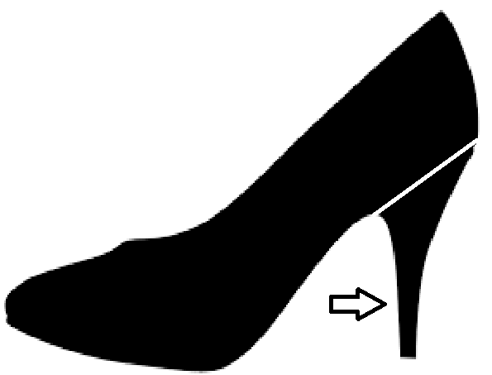

This heel is a simpler design with a slider that allows the heel to slide in and out. This design would allow for the most versatility as the heel could be interchanged for different colors, heights, and styles. The major downside would be the removable part is not desired by users at it would require them to hold on to and not lose the removable heel. The number of parts would be low with the main components relating to the insertion and removal of the heel. The aesthetic of the shoe could be limitless due to the heel variability and the lack of impedance from the design. The height changes could be from a complete flat to even taller than our 3.5 inch goal and everywhere in between due to the ability to use different heels. The removable heel means the heel is not continuous in design and storage of the removed heel would have to occur.

**Pugh Decision Matrix**

The discussion above for each design outlines how well the designs meet the engineering characteristics and major design requirements. From that discussion, the characteristics for each design can be quantified as seen in the pugh matrix below. From there the best design can be chosen.

|  |  |  |  |  |
| --- | --- | --- | --- | --- |
|  | Slider Design | Flip and Slide Design | Folding Heel Design | Removable Heel Design |
| Number of Parts | 2 | 2 | 5 | 5 |
| Aesthetics | 3 | 3 | 4 | 5 |
| Change in height | 4 | 4 | 4 | 5 |
| Continuity | 5 | 5 | 5 | 1 |
| Impede adaptability | 3 | 3 | 4 | 5 |
| Ease of use | 4 | 3 | 4 | 4 |
|  |  |  |  |  |
| Total | 21 | 20 | 26 | 25 |

Out of the four major designs discussed, the folding heel design scored the highest.

This is because the design is simple having three main components: the shoe body, a pin joint, rotational heel. This design also is continuous which was determined in our survey to a very important engineering quality for a convertible high heel shoe. In unison with these qualities, the folding heel design is the only continuous heel design that can be available in a stiletto. While the removable heel design scored higher that the folding heel design in ⅗ categories, its lack of continuity with the removable piece caused a detrimentally low score in this category. The final two designs, flip and slide design and slider design, were more complex due to their high number of parts. Both of these designs were also only available in a wedge style which caused their aesthetics score to be significantly lower than the other two designs,